% 5 CAINE, Wilbert (20584260)

function LAF = linear_average_filter()

A = imread('Fig3.37(a).jpg');

LAF = A;

[row, col] = size(A);

for i = 2 : row-1

for j = 2 : col-1

f = 0;

for s = i-1 : i+1

for t = j-1 : j+1

f = f + uint64(A(s,t));

end

end

LAF(i,j) = f/9;

end

end

subplot(1, 2, 1);

imshow(A);

subplot(1, 2, 2);

imshow(LAF);

end

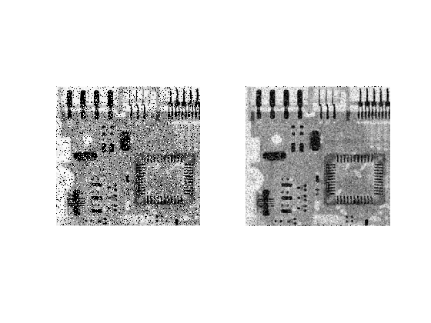

% 6 CAINE, Wilbert (20584260)

function MF = median_filter()

LAF = linear_average_filter();

A = imread('Fig3.37(a).jpg');

MF = A;

[row, col] = size(A);

for i = 2 : row-1

for j = 2 : col-1

f = [];

for s = i-1 : i+1

for t = j-1 : j+1

f(end+1) = A(s,t);

end

end

MF(i,j) = median(f);

end

end

subplot(2, 2, 1);

imshow(A);

subplot(2, 2, 2);

imshow(LAF);

subplot(2, 2, 3);

imshow(A);

subplot(2, 2, 4);

imshow(MF);

end

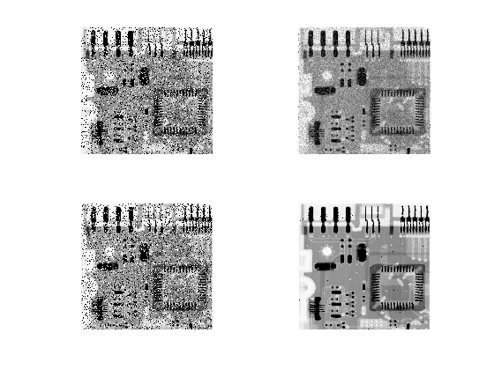

% 8a CAINE, Wilbert (20584260)

function B = svd_for_image_compression(input_image, n)

A = imread(input_image);

[U,S,V] = svd(double(A)/255);

figure(1);

semilogy(diag(S), 'o-');

B = U(:, 1:n) * S(1:n, :) * V';

end

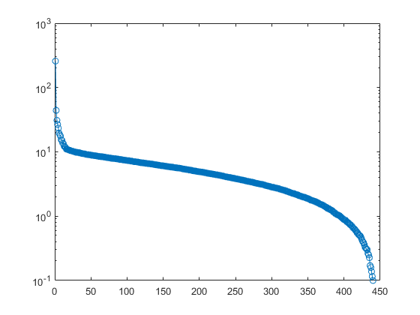

% 8b CAINE, Wilbert (20584260)

original_image = 'Fig3.37(a).jpg';

A = imread(original_image);

for i = 0 : 5

n = 2^i;

B = svd_for_image_compression(original_image, n);

close(1);

figure(2);

subplot(6, 2, 2*i+1);

imshow(A);

subplot(6, 2, 2*i+2);

imshow(B);

rel_err = norm(B, 'fro');

title(rel_err);

end

